**Project Design Phase-II**

**Data Flow Diagram & User Stories**

| Date | 31 January 2025 |
| --- | --- |
| Team ID | SWTID1741244381157552 |
| Project Name | insight-stream |
| Maximum Marks | 4 Marks |

**Data Flow Diagrams:**

A Data Flow Diagram (DFD) is a traditional visual representation of the information flows within a system. A neat and clear DFD can depict the right amount of the system requirement graphically. It shows how data enters and leaves the system, what changes the information, and where data is stored.

**Example:**

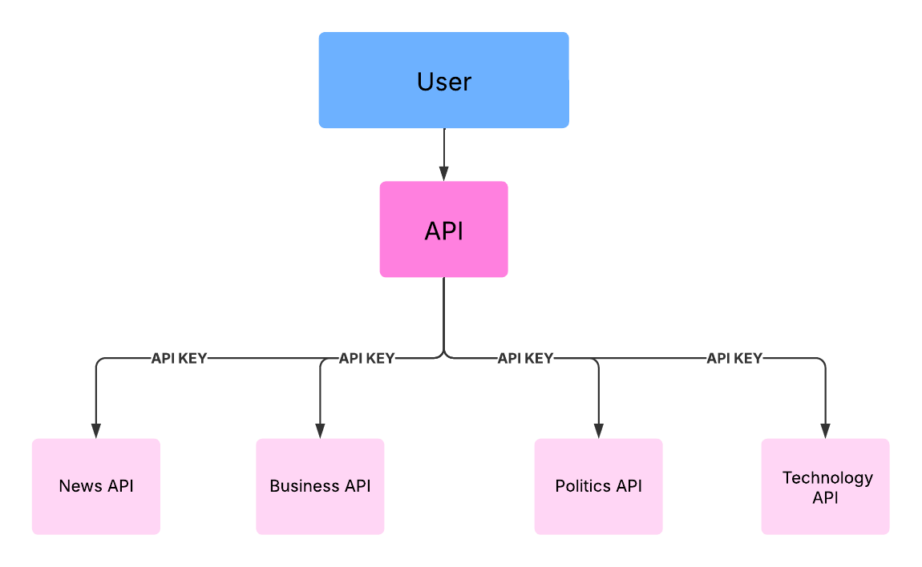

**User Stories**

**User Story Table – Music Streaming App**

| **User Type** | **Functional Requirement (Epic)** | **User Story Number** | **User Story / Task** | **Acceptance Criteria** | **Priority** | **Release** |
| --- | --- | --- | --- | --- | --- | --- |
| **News** |  | USN-1 | As a user, I can see the trendy news . | I can see the News of all topics. | High | Sprint-1 |
| **Genre** |  | USN-2 | As a user, I can watch Political,Business, and Technology News. | I can also go the source and read the full news. | High | Sprint-1 |
|  |  | USN-3 | As a user, I can able to view the complete news across the world. | I can also watch the news for multiple pages . | Medium | Sprint-2 |
| **Subscription** |  | USN-4 | As a user, I can even subscribe. | I can Subscribe to the newsletter for the news . | High | Sprint-2 |